**Installing Magento on centos 7**

**Step1: Disable SELINUX using below command**

**#sestatus**

If it enabled disable using below command go to config file and disable

#cd /etc/selinux/config

Make changes to selinux to disabled**(SELINUX=DISABLED)**

#systemctl restart httpd

Reboot the server

#init 6

Installing apache on centos 7

Step 1:Update Software Versions List

sudo yum update

Step 2: Install Apache

sudo yum install httpd -y

Step 3: Activate Apache

Sudo systemctl start httpd

Step 4:set the Apache service to start when the system boots

Sudo systemctl enable httpd

Step 5: Verify Apache Service

Sudo systemctl status httpd

OUTPUT

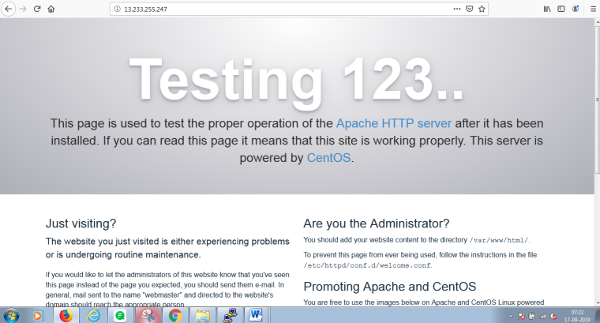

Link https://hostadvice.com/how-to/how-to-install-lamp-stack-on-centos-7/

Installing mysql on centos 7

Step 6:before you install mysql use below command to update and install wget.

sudo yum update

yum install wget

Step 7:MySQL must be installed from the community repository.

wget http://repo.mysql.com/mysql-community-release-el7-5.noarch.rpm

sudo rpm -ivh mysql-community-release-el7-5.noarch.rpm

yum update

step 8:Install MySQL as usual and start the service.

sudo yum install mysql-server

sudo systemctl start mysqld

step 9:Run the mysql_secure_installation script to address several security concerns in a default MySQLnstallation.

sudomysql_secure_installation

step 10:To log in to MySQL as the root user:

mysql -u root –p

**## Creating New User for Magento Database ##**

mysql> CREATE USER **magento**@localhost IDENTIFIED BY "**your_password_here**";

**## Create New Database ##**

mysql> create database **magento**;

**## Grant Privileges to Database ##**

mysql> GRANT ALL ON **magento**.* TO **magento**@localhost;

**## FLUSH privileges ##**

mysql> FLUSH PRIVILEGES;

**## Exit ##**

mysql> exit

---------------------------------

Enter the password and type Exit to come out from mysql.

Installation Steps of PHP 7.0, 7.1 & 7.2 on CentOS 7

Step 1:Install yum-utils and enable EPEL repository

yum install epel-release yum-utils –y

step 2:Download and Install remirepo using yum command

yum install http://rpms.remirepo.net/enterprise/remi-release-7.rpm

yum-config-manager --enable remi-php70

step 3: Install PHP 7.2 along with dependencies.

**Note: for installing magento use the correct php module if you are getting the error while loading the page**

yum install phpphp-common php-opcachephp-mcryptphp-cli php-gdphp-curl php-mysqlphp-intlphp-soap –y

sudo yum -y install php php-pdo php-mysqlnd php-opcache php-xml php-mcrypt php-gd php-devel php-intl php-mbstring php-bcmath php-json php-iconv

step 4: Verify the PHP version

php -v

Step5: start its service using below systemctl command

systemctl start httpd

Now create a**info.php** file under /var/www/html with following contents,

cd /var/www/html/

vi info.php

================

<?php

phpinfo();

?>

Next you will need to configure Apache to use mod_rewrite.

You can do this by editing /etc/httpd/conf/httpd.conf file.

LoadModule rewrite_module modules/mod_rewrite.so

Change the value of AllowOverride None to AllowOverride All.

AllowOverride All

Save and exit and restart apache server

systemctl restart httpd

Open the web browser and type the ip of your server followed by info.php,

<http://Server-IP-Address/info.php>

OUTPUT

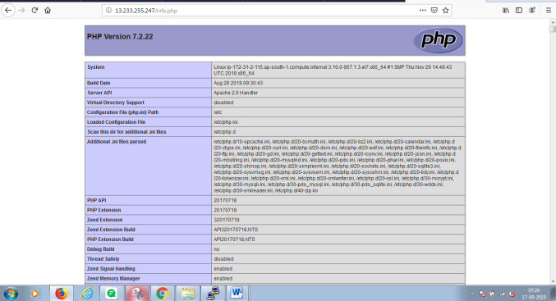

https://www.linuxtechi.com/install-php-7-centos-7-rhel-7-server/

Installing phpMyAdmin on centos 7

step 1:phpMyAdmin is not available in CentOS 7 core repositories. To install phpMyAdmin we need to enable the EPEL repository first:

sudo yum install epel-release

step 2: Once the EPEL repository is enabled we can install phpMyAdmin and all of it’s dependencies with the following command:

sudo yum install phpmyadmin -y

Now we configure phpMyAdmin

nano /etc/httpd/conf.d/phpMyAdmin.conf

<Directory /usr/share/phpMyAdmin/>  
AddDefaultCharset UTF-8  
  
<IfModulemod_authz_core.c>  
 # Apache 2.4  
# <RequireAny>  
# Require ip 127.0.0.1  
# Require ip ::1  
# </RequireAny>  
 Require all granted  
</IfModule>

Save and exit using ESC :wq! enter.

step 3:Restart the Apache service:

systemctl restart httpd

step4:Now you can access the phpmyadmin console by navigating to the URL

http://server-ip-address/phpmyadmin/ from your browser.

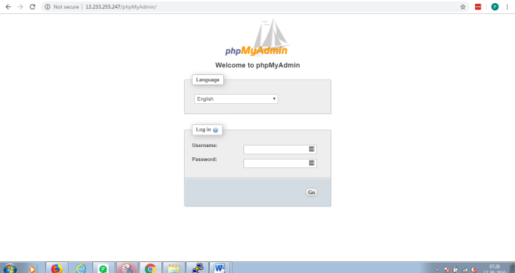

Enter your MySQL username and password which you have given in previous steps. In my case its “root” and passwd

“Parasu@123”.

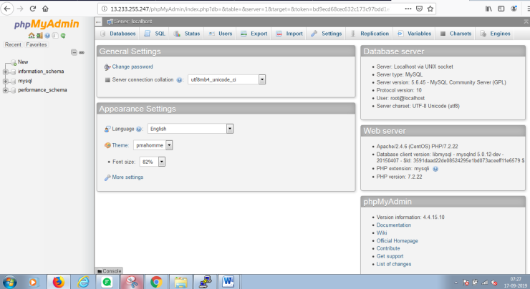

<https://www.howtoforge.com/tutorial/centos-lamp-server-apache-mysql-php/>

**Install Magento Community Edition**

Now, go to the Magento official website, and create a user account in case you a new customer.(or simply login if you already have an account) and download the latest version of Magento Community Edition.

[http://www.magentocommerce.com/download](https://www.magentocommerce.com/download)

step1: Go to above link download the magentozar file in system and then using winscp mv tar file from local machine to server.

The moved file will be store in location

#cd /home/centos/

#ls

Step2:After you download Magento tar file, extract the contents into the Apache Document Root (**/var/www/html**)

# tar -zxvf Magento-CE-2.1.5-2017-02-20-05-36-16.tar.gz -C /var/www/html/

Step 3: Now you need to set Apache ownership to the files and folders.

# chown -R apache:apache /var/www/html/

Step 4: Now open your browser and navigate to the following url, you will be presented with the Magento installation wizard.

<http://server_domain_name_or_IP/>

output

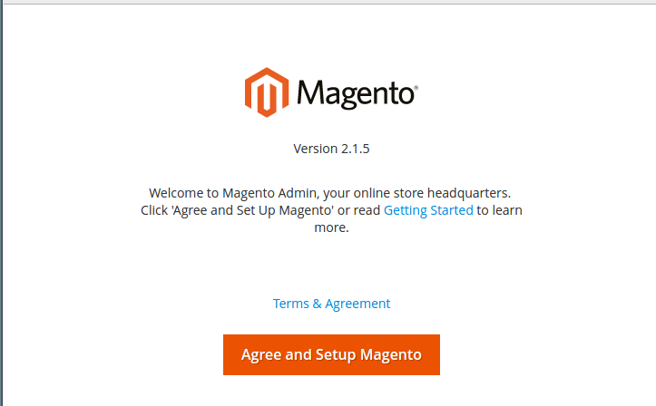

Fill all the details correctly and the get the output. If you see any error like phpextension.intl

Or phpextension.soap it means sum package missing in php module.

Check the php module using below command

#php –m

Installing the missing package and restart the apache

#systemctl restart httpd

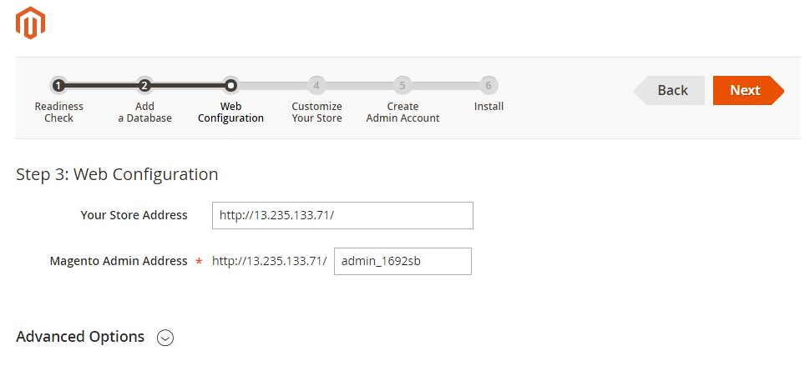

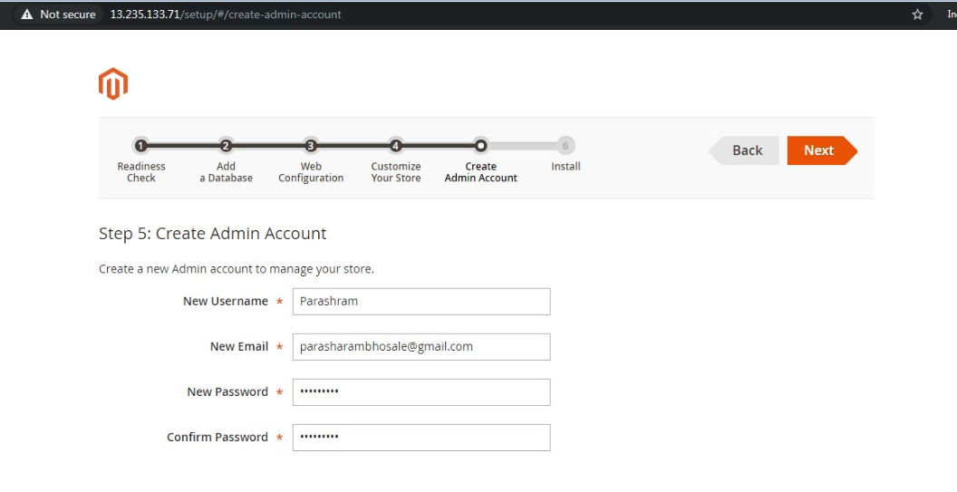

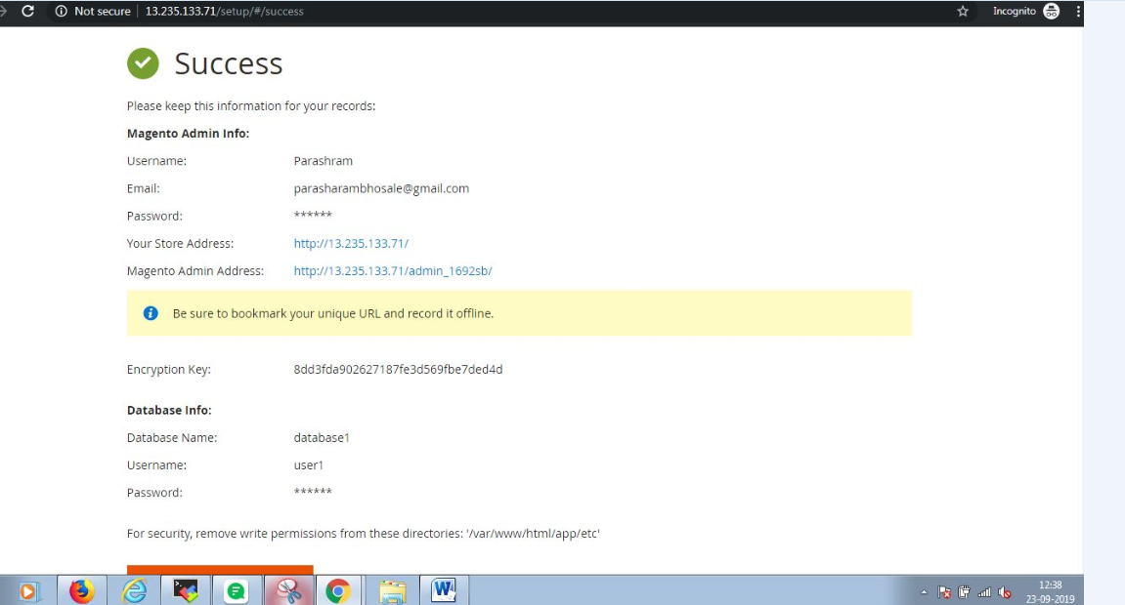

After successful if are getting error it means rewrite module is not enabled**.**

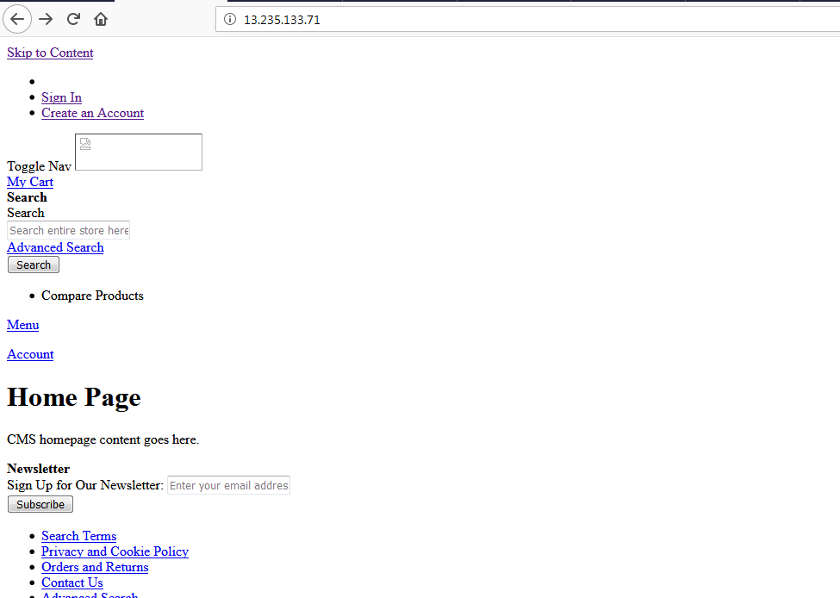

For this error we cant able to login to the main page.

#### Step 1: Check if the module exists

Before enabling the module mod_rewrite, we need to check if the module is already loaded in the httpd file.

# httpd -V

From the above result, we can find out the path of the apache config file (httpd.conf). From the result, we can say that the conf file path is /etc/httpd/conf/httpd.conf for our server.

To check if the module exists, run the command mentioned below,

# ls /etc/httpd/modules | grep mod_rewrite

If module exit you will get the output like

mod_rewrite.so

The chances of not getting this result are rare, but if you don’t get this result you need to install mod_rewrite and compile apache with the module support.

#### Step 2: Check if the module is loaded

Now that we have verified that the module exists in the modules directory, let’s check if the module is loaded or enabled. To do this run the

# grep -iLoadModule /etc/httpd/conf/httpd.conf | grep rewrite

If you see the following result, it means that the module is enabled.

If this result is commented like mentioned below, then remove the comment from the httpd.conf file, then save and exit the file.

#LoadModulerewrite_module modules/mod_rewrite.so

But if you don’t get any of the above results, then add the following line to your httpd.conf file.

LoadModulerewrite_module modules/mod_rewrite.so

#### Step 3: Configure httpd.conf file

Edit the httpd.conf file by locating <Directory /var/www/html> section and change the directive from None to All. Then save and exit the file.

That’s it, you have enabled the mod_rewrite module on your CentOS server.

OUTPUT:

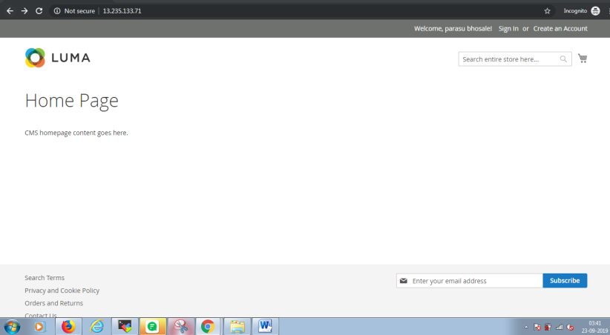

**Link to follow the steps:**<https://www.tecmint.com/install-magento-on-centos-7/>

<https://www.e2enetworks.com/help/knowledge-base/how-to-enable-mod_rewrite-on-apache-on-centos/>

<https://devops.ionos.com/tutorials/how-to-install-and-configure-magento-2-on-centos-7/>

if this is not working please try to install composer

## Install Composer

Composer is an application level package manager for the PHP programming language that provides a standard format for managing dependencies of PHP and required libraries.

To install composer simply run the following command:

curl -sS https://getcomposer.org/installer | php

The above command will download the latest version of the composer.phar file in your home directory.

To use composer, you will need to move it to /usr/bin/ directory:

sudo mv composer.phar /usr/bin/composer

You can verify the version of the composer with the following command:

composer -V

Output:

Composer version 1.2.4 2016-12-06 22:00:51

Check this website

<https://devops.ionos.com/tutorials/how-to-install-and-configure-magento-2-on-centos-7/>